***PROBLEM OF THE WEEK – 02***

***Assignment Given: 13/10/2020***

***Assignment Completed: 21/10/2020***

**PROJECT DISCRIPTION: Write or create a batch file which checks the software version installed and does the following operation on execution.**

|  |
| --- |
| **Option 1): if a version of PYTHON is already installed check its version. If the VERSION is less than 3.6 or NO VERSION is installed then install PYTHON 3.6.0 version.**  **Note: BATCH file should check the installed software version anywhere in the system.**  **Option 2): if Lesser VERSION is present BACKGROUND UPGRADE (Hidden mode update) to 3.6.0 PYTHON VERSION.**  **Note:** BATCH file should perform the process in background so user can’t see the process.  **Option 3):** if PYTHON VERSION 3.6.0 is present Nothing to be done.  **Note:** ECHO message to user that Recommended Software version is installed a running.  **Option 4):** if PYTHON VERSION greater than 3.6.0 is present let user know that 3.6.0 is the VERSION to be installed and make appropriate comment asking for the installing.  **Note:** if PYTHON is not all present in the system it should install 3.6.0 VERSION.  **Option 5):** Install the recommended version if python is not at all present in the system.  **Note:** version check command returns a null empty space |

**Note:**

1. Make all necessary comments and display message corresponding to invalid inputs.
2. If possible try to keep an Error logs for the program.

**Batch File execution:**

1. **Already present recommended version:**

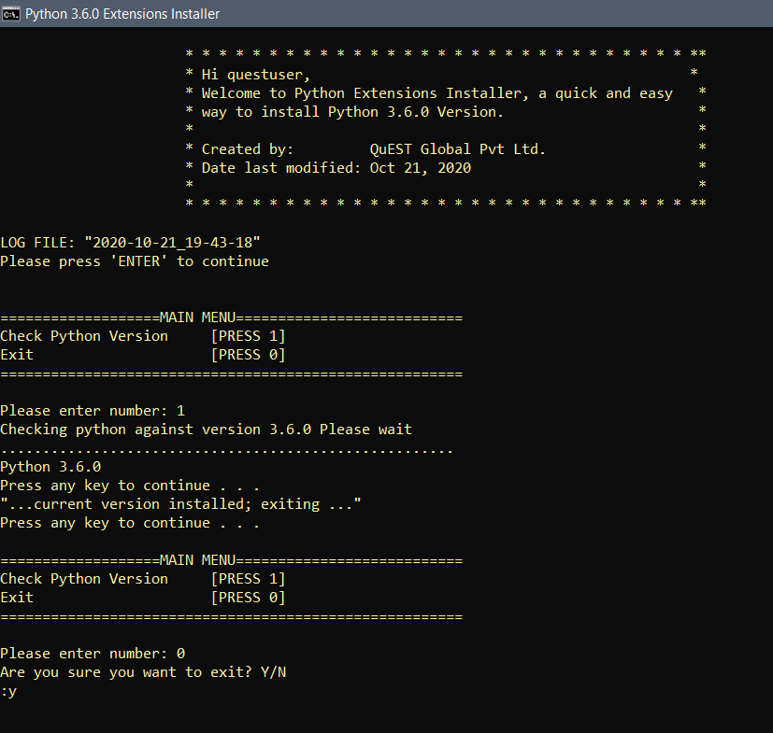

1. **Present with Greater version Function:**

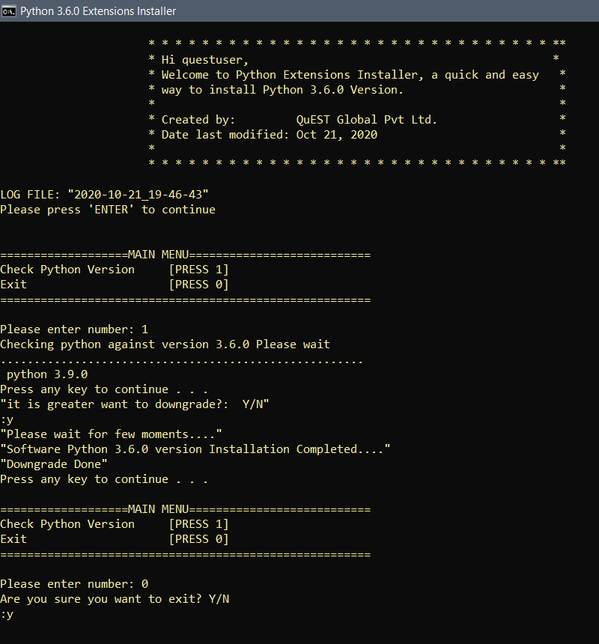

1. **Present with Lower version Function:**

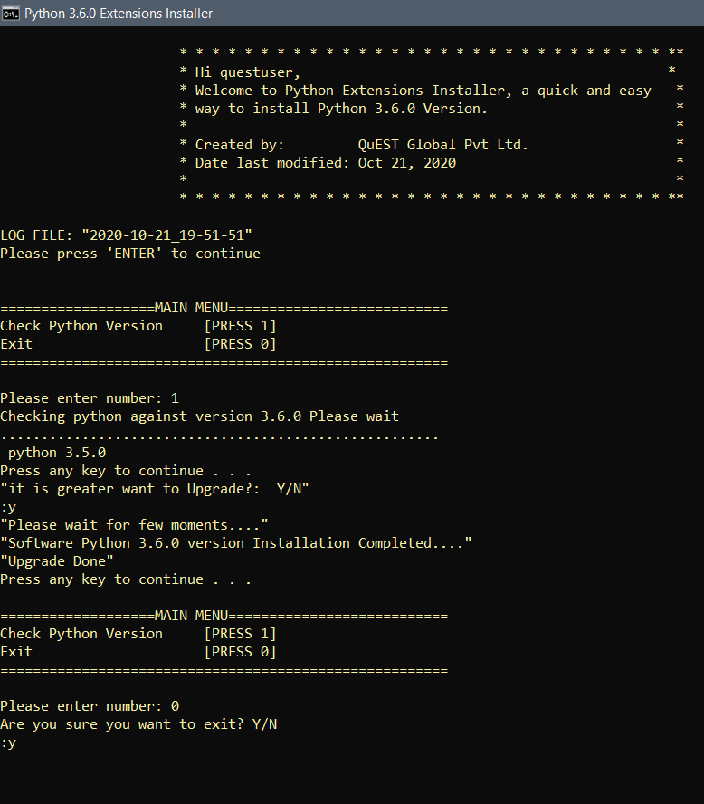

1. **Exit Function:**

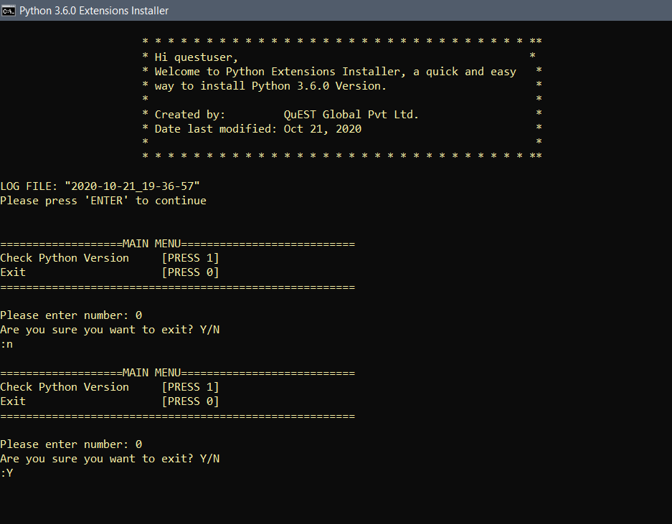

1. **If Python not present Function:**

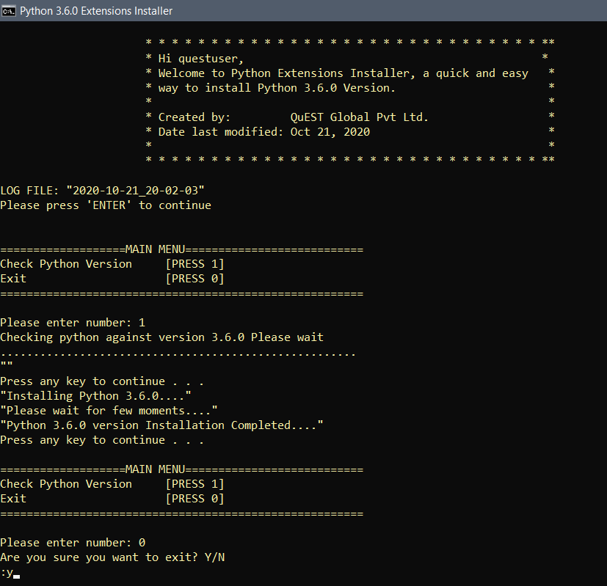

1. **LOG FILE:**

